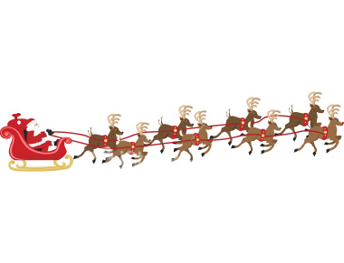
STEAD LANE PRIMARY SCHOOL

Reception Class visit to

Rising Sun Country Park

On Thursday 5th December 2024 our Reception class will be taking part in a workshop in Santa’s Grotto at Rising Sun Country Park. The children will enjoy Christmas crafts and warm juice before visiting the big man himself!

The bus will leave school at 9.15am and return to school at around lunchtime but a packed lunch will be needed on this day in case we are delayed. As part of the free school lunch scheme all Reception children are entitled to a free packed lunch on this day. However, if you would like to make up your own packed lunch from home that is fine but you must inform us of your choice so the kitchen can accommodate everyone.

School uniform need not be worn but please ensure your child is dressed warmly with a waterproof coat in case of rain. Any child who suffers from travel sickness must take medication before leaving home in the morning.

Throughout school your child will take part in some visits paid for in full by school. Our wonderful PTA have kindly agreed to help with the cost of the transport for this visit but we ask for a parental contribution of £7.00 per child.

We realise that Christmas is an expensive time so we are sending you this letter now to give you time to save up!

If you have not already returned your Parental Consent Form which was sent home at the start of the school year, this will be attached and must be completed and returned to us asap along with the reply slip below to allow your child to take part.

Yours sincerely,
- Sullivan
Class Teacher
- - - - - - - - - - - - - " - - - - - - - - - - - - - - - - - - - - - - - - - - - - - - - - - - - - - - - - - - - - - - - - - - - - - - - - - - - - - - - - - - - -

STEAD LANE PRIMARY SCHOOL
RECEPTION VISIT TO RISING SUN COUNTRY PARK

is attending the outing on Thursday 5th December 2024.
.
I enclose £7.00 towards the cost of the outing £
I will make my payment of £7.00 online £

I will supply a packed lunch from home £
I wish my child to have a free packed lunch from school (please choose below): £

Sandwich filling:
Ham □ Chicken □
Cheese □ Tuna Savoury □

Do you want your sandwich in:
Bread □ Wrap □

Do you want salad on your sandwich? YES/NO

