**Over this term we will be covering the following objectives:**

* Use language associated with time – today, tomorrow, yesterday, week, month, year.
* Understand and speak about events in the past, present and future.
* Order a sequence of up to 5 events (daily routine/everyday tasks)
* Discuss why some objects are old and new
* Know about similarities and differences between themselves and others, and among families, communities and traditions.

Key Books for this Half Term:

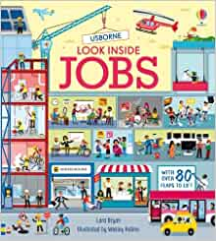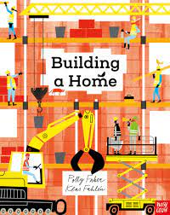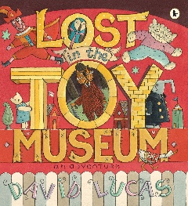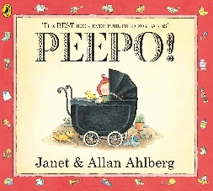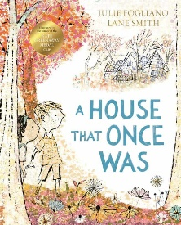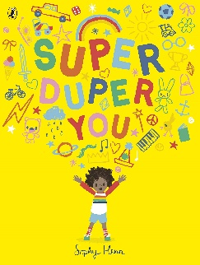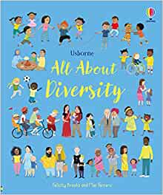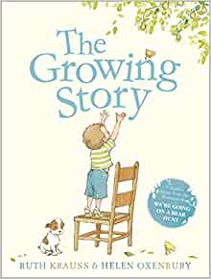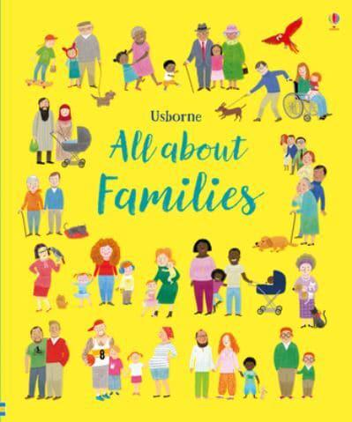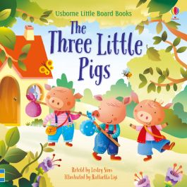

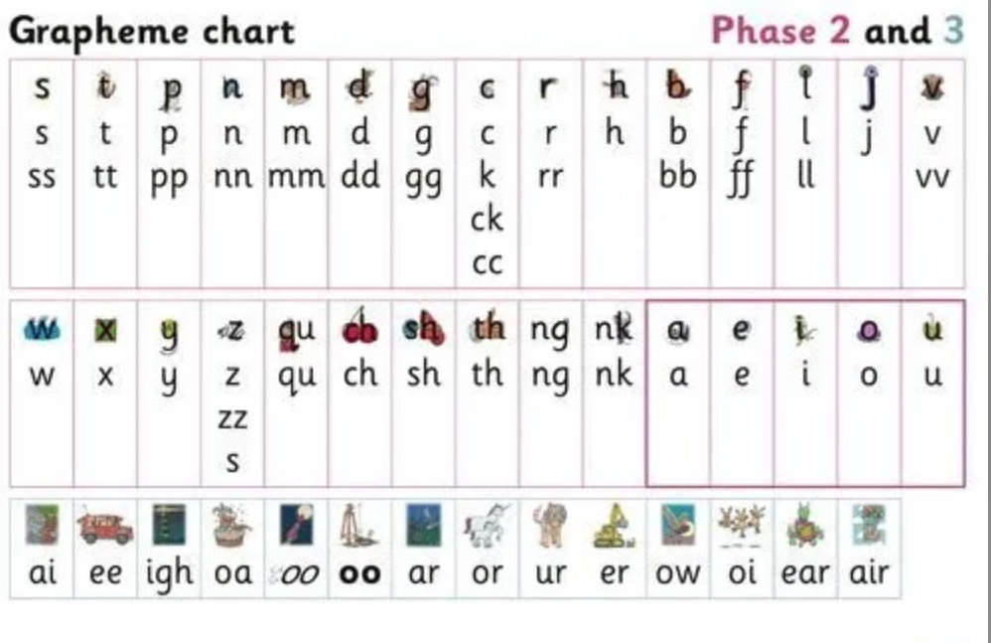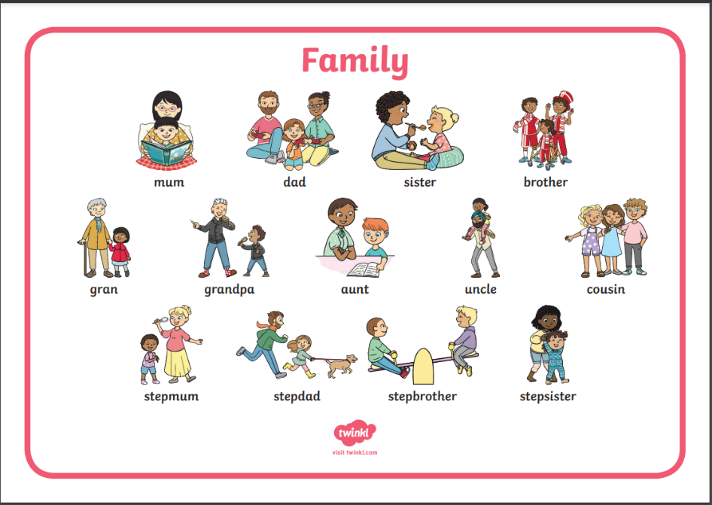

Mathematics:

Instantly recognises collections up to 5 when briefly shown and verbally names the number of items, eg when shown 5 objects, briefly says ‘5’.

Verbally labels all arrangements to 5 shown only briefly.

Will have a deep understanding of numbers to 5.

Begins to show number combinations to 4 then 5.

Beginning to recognise and name some 2D and 3D shapes.

Uses everyday language related to time. Eg days of the week, yesterday, today, tomorrow.

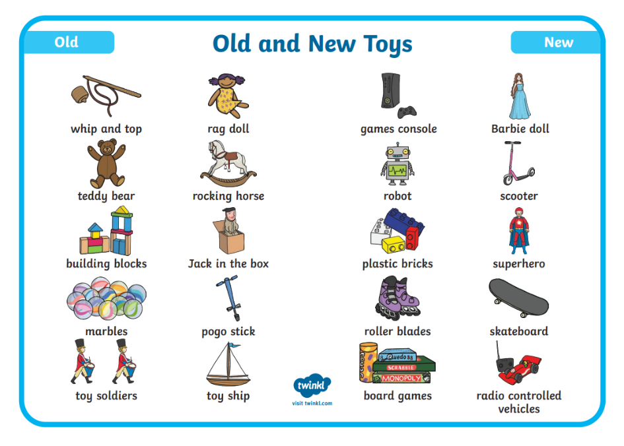

Phonics

To blend 5 syllable words e.g. hipp-o-po-ta-mus.

To recognise most graphemes (letters) including some where 2 letters represent 1 sound.

To consistently hear the initial, medial and final phonemes in cvc words.

We will be learning and re-capping the sounds (phonemes) for each letter of the alphabet, linking each sound to its letter (grapheme). We will also be continuing to practice our handwriting by using the rhyme for each letter to help with letter formation. We will be reading simple words. Look at the letter, make the sounds and blend the sounds together.

Oral Segmenting- This is when you split a word up into its individual sounds (c-a-t).

Oral Blending- This is when you blend the sounds together to say the word (cat). We swipe our finger underneath the word from left to right to help blend the sounds together.

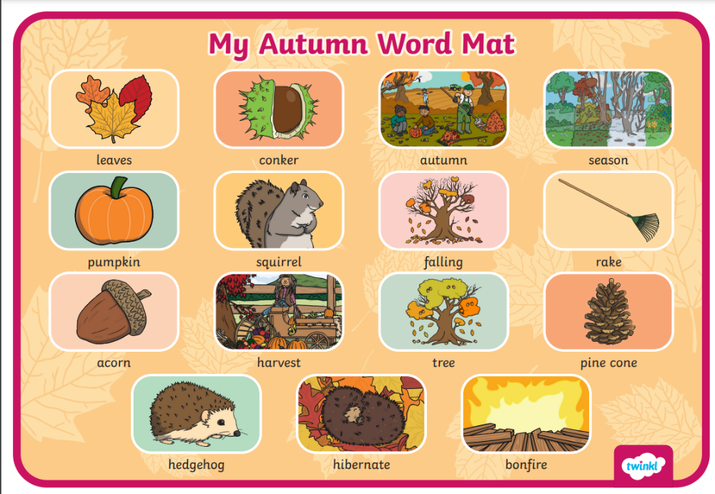

Personal, Social and Emotional Development

Aware of daily routine.

Can organise themselves in the environment.

Will tidy items away safely.

Play cooperatively and look after toys.

Physical Development:

Holds pencil with an effective tripod grip and holds paper with the other hand.

Shows a clear hand preference.

Uses a range of everyday tools effectively.

Uses a knife and fork competently.

Goes to the toilet independently.

Active and skilful in climbing, swinging, digging and sliding.

Bends and touches toes with legs straight.

Gross and fine motor movement using circles, arches and spirals. Fine motor control using dough to practice two finger disco, piano fingers and pinching the dough to develop effective tripod grip.

PE lesson every Thursday