**Autumn 1 Nursery**

**What makes me special?**

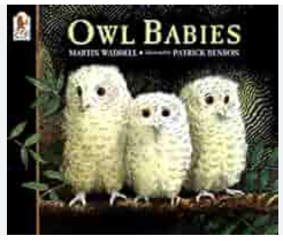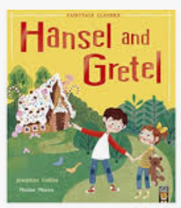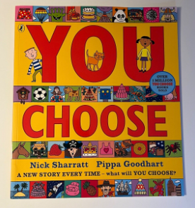

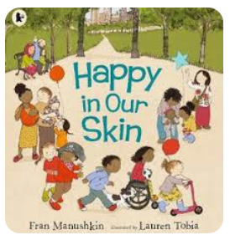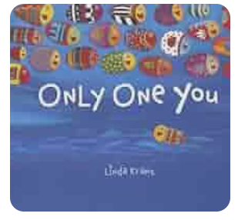

core books teaching books

In nursery there will be core books that we want the children to know inside and out. Learning repeated refrains is key to helping children identify patterns in language and will help prepare them for learning to read when they go to Reception. There will also be some teaching books that will be used to help us discuss and reflect upon our project question for the term, which is “what makes me special?” We will read these stories a few times, but they will not be studied in the same depth as the core texts. Core texts will be revisited throughout the year to help them gain fluency.

Here are some of the skills we will work on this half term as we get to know your child:

We promote independence in self-care which includes dressing themselves, washing their hands and managing their toilet needs, peeling and eating their fruit and drinking from a cup without spilling. You can practise these things at home too!

When reading we are learning to:

* Actively listen to stories by sitting and looking at the book
* Can answer basic questions about the book such as who the main character is in the story and where the story takes place
* Listen for syllables in words and clap them (e.g. el-e-phant has 3 syllables)
* Talk about the meanings of unknown words

Initially in Maths we are learning to recognise quantities of up to three objects, use words to compare different quantities (more, less, same) and use everyday words such as tall, round. We will explore shape through block play and construction activities and start to look at the similarities and differences between shapes.

To help our children understand more about the world, we are:

* beginning to understand and use the language of today, tomorrow and yesterday.
* speaking about an event which has happened in the past and discussing a future event.
* ordering a sequence of up to 3 events, such as things from their daily routine (have a wash/brush teeth, story and bed).
* recognising special times or events for family and friends.

Things you can practise at home:

* Waiting for their turn to speak (not over the top of others)
* Putting on their coat and shoes themselves and carrying their own bag
* Talk about their daily routine using key words “now” and “then” (we are playing inside now, then we will have a snack)

Remember to check Tapestry to see weekly updates on what your child has been doing at Nursery. This is a great thing to do with your child so you can ask them to describe to you what they are doing. Communication and developing language skills is a big focus here in nursery!